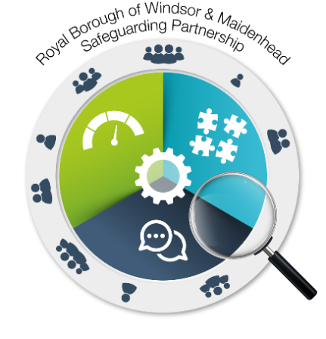

**Action Plan for the delivery of Adult Exploitation through a multi agency Sub Group**

**The themes & actions in this plan are organised under the following priorities: Adult Exploitation**

**BRAG Status Key:**

|  |  |  |  |
| --- | --- | --- | --- |
| **Blue** | **Red** | **Amber** | **Green** |
| **Action complete** | **Action not being implemented or serious delays/concerns identified.** | **Action being implemented but with possible delays/concerns** | **Action being implemented and on track for completion within timescales** |

**Theme - Communications**

| **ACTION NUMBER** | **ORGANISATION** | **ACTION REQUIRED** | **BY WHEN** | **LEAD(S)** | **OUTCOME TO BE ACHIEVED** | **BRAG STATUS** | **ACTIONS COMPLETED WITH EVIDENCE** |
| --- | --- | --- | --- | --- | --- | --- | --- |
|  | Safeguarding Partnership | Continuously using and updating the safeguarding partnership website with information and themes under Exploitation | May 2021 | Karan Sandhu | To inform individuals in the community to raise awareness and understanding of exploitation | Blue | KS developed the safeguarding partnership in May 2020, and since the website has continuously been updated with information around exploitation and the continual use of social media platforms including Twitter has allowed the partnership to disseminate information around exploitation on a daily basis and awareness weeks. |
|  | Adult Exploitation Sub Group | Support victims, families and communities with the knowledge of what to do if they are worried and where to get help by communicating and disseminating information across organisations | Continuous | Hilary Hall with Karan Sandhu | To work with partner agencies to raise public awareness of exploitation in the Royal Borough and ensure the public know how to report concerns | Blue | KS developed the safeguarding partnership in May 2020, and since the website has continuously been updated with information around exploitation and the quarterly safeguarding newsletters have been designed to incorporate information in which people are aware of how to report issues and concerns. |
|  | Adult Exploitation Sub Group | Educate professionals, local organisations and communities to identify signs of vulnerability. Be absolutely committed to preventing exploitation in corporate activities and have zero tolerance for any type of exploitation. | Continuous | Hilary Hall | Individuals in all agencies will understand the issues of exploitation; the duty to notify; how their agency can support multi-agency work | Blue | At the Adult Exploitation in July, members of the group agreed that the safeguarding partnership is valued as a key resource to help educating professionals, local organisations and communities to be able to identify signs of vulnerability. KS has continued to update the website since and has also used social media networking sites such as Twitter to disseminate key information around vulnerability and exploitation as a whole to generate a wider awareness across the borough. |

**Theme – Areas under Exploitation**

| **ACTION NUMBER** | **ORGANISATION** | **ACTION REQUIRED** | **BY WHEN** | **LEAD(S)** | **OUTCOME TO BE ACHIEVED** | **BRAG STATUS** | **ACTIONS COMPLETED WITH EVIDENCE** |
| --- | --- | --- | --- | --- | --- | --- | --- |
|  | Adult Exploitation Sub Group | The group is to analyse themes surrounding exploitation – (County Drug Lines, Modern Slavery, Fraud) and underpin ways of effectively minimising this and preventing exploitation within the local community | July 2021 | Hilary Hall | Analysing the main themes under exploitation and understanding what can be done by multi-agency partners and organisations to help reduce exploitation in the local area. | Blue | Some analysis of Modern Slavery and CDL’s was identified by the Superintendent of Thames Valley Police and was shared with the group late 2020. |
|  | Adult Exploitation Sub Group | Support law enforcement’s approach to disrupting and prosecuting perpetrators. | TBC | *TVP* | To increase the amount of intelligence being shared with Thames Valley Police and support multi-agency partners with any operation work | Amber |  |
|  | Adult Exploitation Sub Group | Link work being undertaken being carried out by the Community Safety Partnership and support the team with work through the exploitation strategy | TBC | Hilary Hall & Louise Warbrick | Ensure there is no work duplicated and help the Community Safety Partnership to ensure no work is lost through the Exploitation Strategy. | Blue | At the group meeting in April 2021, the group discussed ways in which to ensure no work was being duplicated between the different sub groups across the local area. Louise Warbrick and Daniel Bayles have continuously worked together and confirmed that the work being tied in from the Adult exploitation group is not being duplicated, and Louise also confirmed that work being carried out by the County-drug lines group Youth Violence and County Drugs Line Disruption sub group is made aware of progress we have made. |
|  | Adult Exploitation Sub Group | Agree the practical arrangements for the establishment of a formal multi-agency exploitation case conference (AEMRAC) | TBC | All | Develop a plan for the Adult Exploitation to carry out AEMRAC and monitor under the sub-group. | Amber |  |
|  | Adult Exploitation Sub Group | Develop an Adult Exploitation indicator analysis tool, similar to the Children’s tool which can be used by multi-agency partners for future analytical case audits. | April 2022 | Adult Exploitation Sub Group | Widely spread the use of the tool across the Borough for multi-agency partners to use when dealing with vulnerable adult/s. | Amber |  |