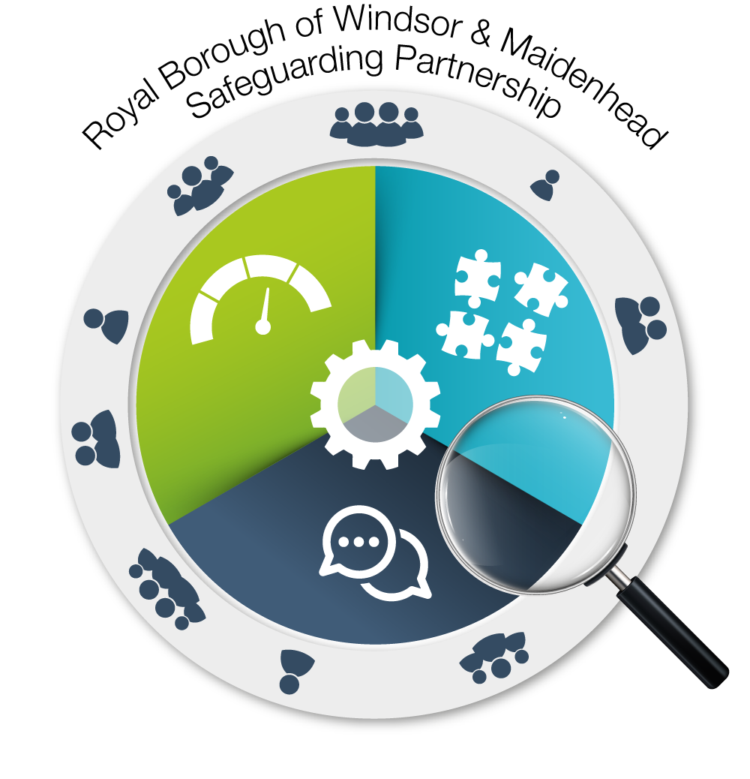

Safeguarding Adults Review request form

Details of individual/ organisation requesting the SAR:

Name
Position/Designation
Organisation
Address
Contact telephone
Contact email

Authorising Manager
Position/Designation
Contact telephone
Contact email
Date of request

Details of adult at risk:

Name
Address
Date of Birth |  | Date of Death (if applicable)
Ethnicity
GP (if known)
Family / NoK / Advocate / representative
Health and/or other presenting needs

Details of person / organisation alleged responsible for harm
Name
Address
Date of Birth |  | Date of Death (if applicable)
Ethnicity
GP (if known)
Relationship to adult at risk
Health and/or other presenting needs
Details of SAR request:
Brief outline of the case/incident (with dates and locations if known)

What learning do you think can be achieved through a review of this case?

Has any other learning / review process already been followed (e.g. internally)? Yes |  | No
If yes, please specify the review conducted, learning identified, how it was disseminated, and impact.

List of individuals and their agencies/service providers known to be involved in the case.

Any other relevant information that will help the SAB decide whether a SAR is required.

Summary of why this case meets the criteria for a Safeguarding Adult Review (see section 2 in the SAR Framework)
Please establish the link between cause of death / harm and the (suspected) abuse / neglect.
Please include the views of the adult / family / carer where known

Do you believe a statutory Safeguarding Adult Review is required in response to this case? Yes / No

Once this form is completed please return to the following email address: safeguarding.partnership@rbwm.gov.uk

