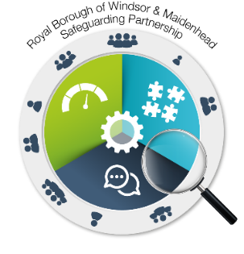

*The Safeguarding Partnership would like to thank Slough Children’s Services Trust for allowing us to use this information.*

**Private Tutoring Leaflet**

**Help and guidance for parents on choosing a private tutor**

There are many reasons why a parent/career might want to employ a tutor. It may be to help their child improve their exam grades, to assist with their schoolwork, for additional home schooling, learn a musical instrument or to study religious texts. This leaflet is designed to help you make an informed choice when choosing a tutor to work with your child.

Children learn best when they are relaxed. Private tuition is usually extra time beyond schooling time. A child may become tired after a day at school, so timing needs to be carefully considered when sending your child to a tutor.

It is important for parents/careers to know that there are no regulations that govern tutors and cost does not necessarily indicate excellence.

Local authorities and schools cannot provide a list of approved professionals who work as tutors. Therefore, it is the parents/careers responsibility to make sure the tutor is suitably knowledgably in the subject and has the correct safeguarding documentation, a DBS check in place. Research can be done online as there are many approved tutor websites available. Tutoring agencies may charge much more than what the tutor gets paid, but they usually have safeguarding systems in place. It is always safer to ask the tutor of their safeguarding principle or their DBS certificate to be sure.

**I am worried about my child’s progress at school—what should I do?**

Before embarking on your quest for the perfect tutor, look carefully at your child’s academic strengths and weaknesses. Review their work to determine the areas that would benefit from a close focus and speak to you child’s teachers. Their teachers will have a familiarity with your child which will provide valuable insight for what area of learning will benefit from a tutor.

Talk to your child about tutoring so you can gauge the commitment and the attitude they’re likely to show in lessons, as well as their level of interest and confidence in the subject. Children learn best when they are relaxed. Be mindful of the extra hours they are asked to put in after school when they will already be tired.

**What tutoring options are available?**

You can consider 121 tuition either at your home address or at the tutor’s home, a group tuition, or an online tuition.

**How can I find a reputable tutor to work with my child?**

· Local paper or an online search

· Some schools may have details or knowledge of local tutors

· Recommendations from other parents

**What to do if a child is worried about their tutor?**

* As the tutor’s employer, you have the right to terminate the tuition at any time.
* Make sure your child knows that they should talk to you if anything that happens which scares, upsets, or makes them feel uncomfortable when having their tuition session.
* Listen to your child if they state something inappropriate that has taken place even if you feel angry and upset. Reassure them they have done the right thing to tell you and that what has happened isn't their fault.
* If the tutor has acted in a way that is harmful, abusive, or inappropriate towards your child, it is important that you contact the Local Area Designated Officer (LADO). The LADO manages allegations against individuals who work or volunteer with children. The LADO will discuss your concerns with you and decide what further action needs to be taken.

**What to do if you have a concern about a tutor?**

If you think your child is in immediate danger, contact the police on 999. If you're worried about your child but they are not in immediate danger, you should contact one of the following:

* Contact LADO via MASH – 01628683202 or LADO@achievingforchildren.org.uk
* Contact the NSPCC Helpline on [0808 800 5000](tel:08088005000) or by emailing [help@nspcc.org.uk](mailto:help@nspcc.org.uk).
* Contact your local child protection services. Their contact details can be found on the website for the local authority the child lives in.
* Contact the police.

Royal Borough of Windsor & Maidenhead LADO can be contacted at: [**LADO@achievingforchildren.org.uk**](mailto:LADO@achievingforchildren.org.uk)

For all allegations against Staff and Volunteers, please contact LADO via the MASH or call 01628 683202 or 07774 332675.

All services and functions of the LADO will be managed and completed in the same way

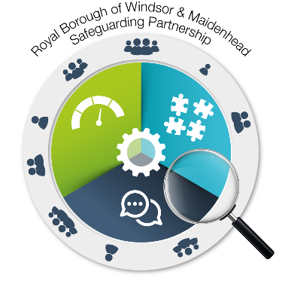

**Unregistered settings**

**What is an unregistered setting?**

An unregistered Educational Setting provides ‘full-time’

education to children of compulsory school age, but

teach a curriculum that is too narrow for the setting to

constitute a ‘school’. The consequence is that they

cannot be registered and therefore regulated.

The criteria to be determined as an unregistered education setting is:

* Teaches a full-time education to five or more children aged between 5-16 years old
* Teaches a full-time education to any number of children where at least one of the children is in care or has special educational needs or an education, health, and care plan.

**Unregistered settings around home tutoring**

Current rules mean that if a tuition centre is teaching for more than 20 hours a week, it must register with Ofsted. Although centres teaching for fewer hours do not need to register, the government is now consulting on plans to regulate centres which teach for more than 6 to 8 hours a week. It is important to note that there is no list of 'approved tutors' that is held by the local council.

A private tutor doesn’t have to be registered with the local authority. It is not a legal requirement for tutors to have a DBS check.

**What to do if you come across an unregistered setting.**

If you have reason to believe that a school or private tutoring arrangement is unregistered, you should report it to the Local Authority who may ask Ofsted to investigate further.

Anyone can check the list of registered schools in England by conducting a search of the Ofsted website If you have concerns, you can contact Ofsted direct on 0300 123 1231.

**What checks should I consider when considering a private tutor?**

Any tutor should understand that you are taking steps to make sure your child is safe and should be happy to provide any information you request from them. Some information that you can ask for from the tutor could be:

* Is the tutor suitably qualified in the subject? Ask to see their qualifications.
* Do they have tutoring experience?
* Does the tutor have a current Disclosure and Barring Service (DBS) check? Please ask to see a copy, even if they are part of a center.
* You should seek recommendations, references and testimonials from other parents/careers who have used them.
* Good, qualified tutors may be already registered with other professional bodies and may hold Qualified Teacher Status (QTS) and work in schools or as examiners.

**What to consider when choosing the right tutor for your child**

Making sure your child has the right tutor is very important with progressing with their education. Some factors you should consider when choosing a tutor for your child is:

* Meet the tutor beforehand and check your child is comfortable with them. Observe their interactions.
* What are the exams results like with other children they have tutored in the past?
* Agree goal and tracking progress over the period of time they are employed.
* Agree a payment plan in advance.
* Ask about their teaching methods
* Ask about which examination boards they are familiar with so your child and the tutor are aligned.
* Are they happy to liaise with your child’s school teacher if required?

Email: safeguarding.partnership@rbwm.gov.uk

**Where should tuition take place?**

Wherever tuition takes place you or another trusted adult should always remain in the building and have access to the teaching area.

* If you are choosing an online tutor for your child, ensure you are able to able to hear the session and have appropriate settings on your child’s system.
* If the tuition will take place in your home, ensure the session takes place in a quiet location away from distractions but in an open environment where you can see and hear them.
* Some tutors hold their tutoring sessions from their home. In these instances, ask about their hone working policy and go and visit the location beforehand to make sure it is safe.
* Tuition should never happen in a bedroom even it contains a study area.

Make sure your child knows where their tuition should take place and ask them to tell you immediately if the tutor tries to change the arrangements, even if that means interrupting the lesson.